**Code: Calculator using TypeScript:**

function func_add(x:number,y:number):void{

let a:number = x+y;

console.log("Addition: " + a);

}

function func_sub(x:number,y:number):void{

let a:number = x-y;

console.log("Subtraction: " + a);

}

function func_mul(x:number,y:number):void{

let a:number = x*y;

console.log("Multiplication: " + a);

}

function func_div(x:number,y:number):void{

let a:number = x/y;

console.log("Division:" + a);

}

var num1:number =20;

var num2:number=30;

(func_add(num1,num2));

(func_div(num1,num2));

(func_sub(num1,num2));

(func_mul(num1,num2));

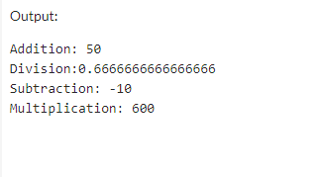

**Code: Function Overloading**

function add(a:string, b:string): string;

function add(a:number, b:number): number;

function add(a:string, b:number): any;

function add(a: any, b:any): any {

return a + b;

}

//Result

console.log("Concatenation: " +add("Hello ", "Ram"));

console.log("Addition: "+add(30, 20));

console.log("Concatenation: "+add("Ram ", 129));

